Personal profile

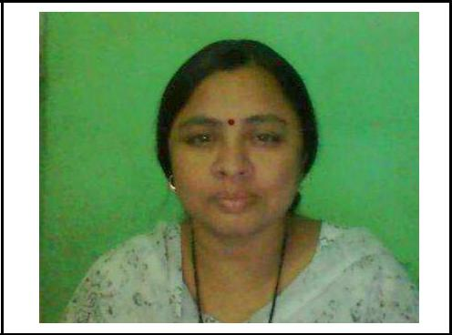

Name: Chaudhari Suvarna Gunvantrao
Edu. Qua.: MSc Microbiology
Email: osd.suvarna@gmail.com
Contact No.: 9767133174, 7982815669
Linguistic proficiency: English, Marathi, Hindi

Educational qualification

Exam | Univercity/board | Year of | Marks | Percentage | Class
passed |  | passing | obtain
MSc (micro.) | Aurangabad | 2012 | 842 | 70.16 | First
BSc(micro.) | Aurangabad | 1992 | 2267 | 61.27 | First
HSc | Aurangabad | 1989 | 363 | 60.50 | First
SSc | Aurangabad | 1987 | 394 | 56.28 | Second

Mrs. Chaudhari S. G. has registered for PhD under the guidance of Dr. R. D. Joshi,

Asst. Prof. at Yogeshwari Mahavidyalay Ambajogai. She completed her PhD course work with A grade and published two research papers on the PhD research topics.
Research experience

1: Desertion entitled,“Studies on Production of Alk aline protease from Bacillus spp. Isolated from farm soil of Malkondaji Village, (M.S.) as a part of MSc Degree at Dept of Microbiology Dr. B. A. M.U.,Sub Campus Osmanabad during academic year 2011-2012.

2: Experience to guide Desertion of PG student titled, “Studies on Isolation of Antimicrobial Actinomycetes from Osmanabad soil”, a t Dept. of Microbiology Dr. B. A. M.U., Sub Campus, Osmanabad during academic year 2013-2014.

3: Experience to guide Desertion of PG student titled, Studies on Isolation of Methicillin resistant Staphylococcus aureus from pus sample” at Dept. of Microbiology Dr. B. A . M.U., Sub Campus, Osmanabad during academic year 2014-2015.

4: PhD Research work on the topic, “Microbial Fuel Cell an alternative and Renewable source of Electricity generation” at Dept. of Micro biology, Dr. B. A. M. U., Sub Campus, under the guidance of Dr. R. D. Joshi, Asst. Prof. at Yogeshwari Mahavidyalay Ambajogai. Osmanabad.

